The University of Tokyo Donation Form

Date:

To: the President of The University of Tokyo

I would like to make the following contribution to the University of Tokyo.

Contributor (company, group):

Address:

Name (representative person):

Signature:

For the encouragement of the research, I contribute to your university.

1. The amount of contribution: USD xxx,xxx
✔ I understand that, in accordance with the University of Tokyo (UTokyo) guidelines, 10 percent of donation to be utilized as research support fund to support the general operation and basic infrastructure of UTokyo and the International Research Center for Neurointelligence (WPI-IRCN). Of the 10 percent, 5 percent shall be allocated to UTokyo and 5 percent shall be allocated to WPI-IRCN.
✔ I understand that UTokyo's investment returns generated from the donation will be incorporated into the UTokyo Endowment Foundation.

2. Contribution purpose and condition:
Purpose: To support the activities of the International Research Center for Neurointelligence (WPI-IRCN), the University of Tokyo
Condition: No conditions specified
✔The above donation does not fall under the ‘Conditions for Refusal of Donations’ set forth by UTokyo. The University of Tokyo Regulations on Donations

3. Donation invoice:
Upon acceptance of my donation request, UTokyo shall provide me with bank account information for funds transfer via email. I shall not be obligated to remit payment of my donation until my receipt of such donation invoice.

*Please also fill out the overleaf.

Contact Information

Please provide the following details to complement the information on the preceding page. A formal acknowledgement letter will follow after the gifts have been received.

Person in Charge:
Full Name
Company, Department
Contact  Info. | Tel
Contact  Info. | Fax
Contact  Info. | e-mail
Remark
Please check the box if you do not wish to receive communications from WPI-IRCN about science events or other updates, apart from those necessary for processing your donation. ☐

Digital recognition board:
We warmly invite you to write a message for our researchers, should you wish. Dedications will be shared on our digital recognition board anonymously.

The names of contributors who have donated a cumulative amount of 300,000 JPY or more are displayed on the board. If you would prefer NOT to have the name displayed on it, please kindly check this box. ☐

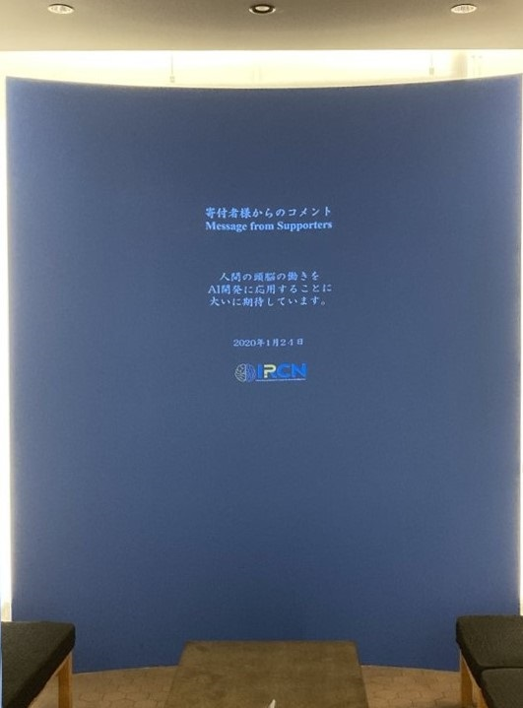 The digital recognition board in WPI-IRCN

